**Rasgulla - Bengali Rasgulla Recipe - How to make Rasgulla**

[http://farm9.staticflickr.com/8084/8296887824_90ae30e9da_o.png](javascript:window.print())

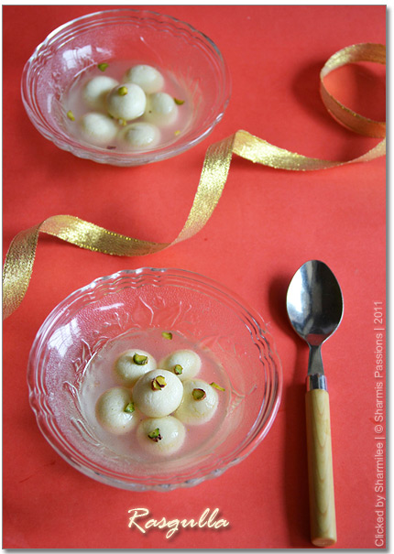

Rasgulla is

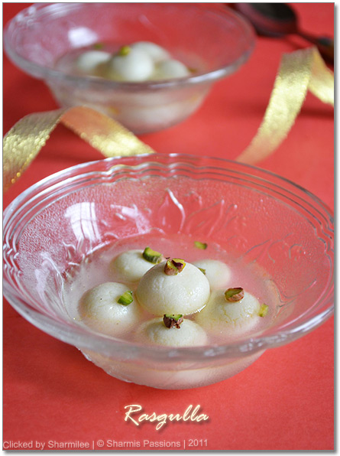

**Rasgulla Recipe**

Milk - 1/2 litre, Lemon Juice - 1.5 tbsp (or) Curd - 2 tbsp, Water - 1 and 3/4 cups, Icecubes - 4 to 5, Sugar - 3/4 cup, Cardamom powder- a generous pinch, Pistachios - 3 to 4 chopped finely for arnishing.

**Method:**

First start with milk, Heat milk bring it to boil and simmer it. Take 1.5 tablespoon lime juice from a lemon and keep it ready. When milk starts boiling, add the lemon juice to the boiling milk and mix properly. Stir incessantly till the whey water clears and the milk curdles totally. Before adding ice cubes you can take some whey water which can be kept for future use which is what I did. Now switch off the stove, add ice cubes and allow it to melt completely. Take a muslin cloth and pour the curdled milk, filtering the whey water completely. Wash it well in running cold water to remove the lemon smell. Squeeze the excess water and hang it aside for 30mins without disturbing it. After 30mins, the paneer would be crumbly in texture. Now knead it well for 10mins. Once everything comes together to a smooth pilable dough, form them into smooth mini/normal lemon sized balls and keep aside. I made around 13-15 mini balls. Heat water in a wide bottomed vessel, then add sugar, cardamom powder and keep stirring till sugar dissolves completely. When the sugar sauce boils and starts bubbling, add the balls slowly one by one and simmer it for 3mins.The balls will go to the corner, move them to the middle. Keep in medium flame and close with a closure. Cook for 10mins opening the lid every 3-4 mins this is to ensure the vapour passes out not allowing the sugar syrup to ooze out. After 10 mins, the balls would be closely doubled in size.

